WPF Interview Project

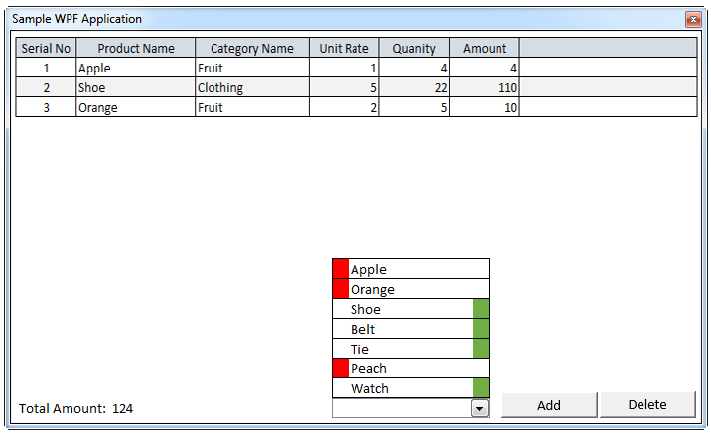

**Rules / Requirements**

* You have two(2) hours to complete this assignment
* You are allowed to use the internet
* Code-behind is not allowed
* Build and populate the combo box as shown above with a red swatch on the left for ‘Fruit’ items and a green swatch on the right for ‘Clothing’ items.
* Clicking the ‘Add’ button will insert the selected item’s information from the combo box to the Grid.
* Only allow user to Add each item once to the grid from the combo box. For example, Apple can’t be added twice to the Grid.
* Prompt the User with ‘Unable to Add Item to the Grid’ dialog when user attempts to add item twice.
* Clicking the ‘Delete’ button will delete only the selected row from the grid.
* Prompt the User with ‘Delete Row – Are You Sure?’ Dialog upon clicking the delete button. User should have the option to ‘Cancel’ or ‘OK’ in the dialog.
* Serial No, Production Name, Category Name, and Amount columns in grid are read-only
* Serial No value in grid is auto-generated and sequential
* Unit Rate, Quantity columns in grid are editable and can’t be negative
* Change in Rate or Quantity in grid should compute and update both the row Amount as well as Total Amount on the bottom of the application.
* **Please read the Bonus section below also before starting the test.**

**Bonus Requirements (Optional)**

* For this” bonus” section, you will have an extra hour if you choose to do so. Inform us ahead of time that would like attempt this as well.
* You have two options to choose from
  1. The business requirement is such that there is a need to frequently change the columns shown in the grid. Please implement it so it doesn’t require adding each new column manually in XAML every time the product owner requests to add a new column for display.

OR

* 1. Build a bar chart that reflects the data added to the grid and is updated as the Grid is updated. The bar chart should allow the user to see Amount per Category Name for quick compare.

**Assumptions**

Scope of the project will change/increase over time – assume you are building this application for long-term use.

**Logistics**.

* Please find a 2-3 hour window where you are able to dedicate time to work on this assessment.
* This is a timed assessment to be completed in a continuous manner via honor system.
* You can use any tools you typically use (Visual Studio, any third party tools) to do the development work.
* Please notify via the provided email(s) when you are starting the test.
* Please notify via email(s) when you have completed it and along with this email send us a zip file(extension renamed to avoid spam filters) of your project.
* Optionally, you can also create a GITHUB repo ahead of time and send us the link along with the start and end times you used for the assessments. If using GITHUB Repo, please ensure you are done checking in files in the allotted time.
* Please let us know if the above options do not work for you. We can figure out alternatives.
* We will provide the project description 15 minutes before the chosen time slot.